|  |
| --- |
| **CARATTERISTICHE TECNICHE/CARACTERISTIQUES TECHINIQUES**  **TECHNICAL CHARACTERISTICS/TECHNISCHE DATEN**  **CARACTERISTICAS TECNICAS** |

**FRIGO TOP FT 45RT-D**

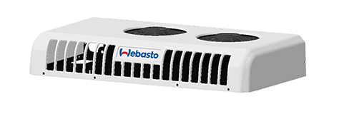 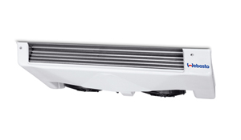

**H1**

**L1**

**W1**

**W**

**H**

**L**

|  |
| --- |
| **Dimensionne / Maß** |
| L | 1115mm |
| W | 665mm |
| H | 180mm |
| http://www.autoera.lv/published/publicdata/JUKKASHOP/attachments/SC/images/weight.png | 34 |

|  |
| --- |
| **Dimensions / Maß** |
| L1 | 1135mm |
| W1 | 530mm |
| H11 | 150mm |
| http://www.autoera.lv/published/publicdata/JUKKASHOP/attachments/SC/images/weight.png | 22 |

|  |  |
| --- | --- |
| R404A | R404A |
| **Potenza frigorifiera**  **Puissance frigorifique**  **Cooking power**  **Kuhlerleistung**  **Potencia frigorifica** | **Potenza frigorifiera**  **Puissance frigorifique**  **Cooling power**  **Kuhlerleistung**  **Potencia frigorifica** | **Portata aria**  **Débit d’air**  **Air flow**  **Luftmenge**  **Capacidad aire** | **Volume cella**  **Volume du compartiment**  **Compartiment volume**  **Kuhlraum Volumen**  **Volumen camara** | **Assorbimento**  **Absorption**  **Rated power**  **Aufnahme**  **Absorcion** |
|  |  | m3/h | m3 | Amp |
|  |  |  |  |  |
| 4910W |  | 2860 | 24.6 (12V)  15.2 (24v) | 42 |
|  | 2520w | 2800 | 13 (12v)  7.4 (24v) | 21 |